AB Associates Anti-Slavery and Human Trafficking Policy and Statement

Introduction
AB Associates Ltd is committed to conducting business ethically and with integrity, ensuring that slavery and human trafficking do not take place within our business or our supply chains. This Anti-Slavery and Human Trafficking Policy and Statement outlines our commitment to combatting all forms of modern slavery in compliance with the UK Modern Slavery Act 2015.

Purpose
The purpose of this policy and statement is to:
- Demonstrate AB Associates’ commitment to preventing slavery and human trafficking in our business operations and supply chains.
- Establish clear procedures for identifying and managing risks related to modern slavery.
- Ensure all employees, contractors, and business partners are aware of their responsibilities regarding anti-slavery practices.

Scope
This policy applies to all employees, contractors, and any other individuals or entities working with AB Associates. It also extends to our business relationships, including suppliers, clients, and partners, regardless of their location.

Company Structure
AB Associates is a private company providing consultancy services to the health, social and care sectors. The Company has 2 Directors and uses a network of consultants and associates, who are predominately educated to a graduate level, and whom we recruit in accordance with robust HR policies. We operate primarily in the United Kingdom.
Our supply chains include ICT service providers, hardware suppliers, and professional services providers. AB Associates works with several partner organisations, which include major international ICT providers, in order to deliver services.

Our Commitment
AB Associates has a zero-tolerance approach to modern slavery and human trafficking. We are committed to:
- Acting ethically and with integrity in all our business dealings.
- Implementing effective systems and controls to prevent slavery and human trafficking in our operations and supply chains.
- Complying with all relevant legislation and best practices related to modern slavery.

Risk Assessment and Due Diligence
  - Risk Assessment
- AB Associates will conduct regular risk assessments of our business operations and supply chains to identify and mitigate risks of modern slavery.
- We will prioritize high-risk areas, such as industries or regions with known issues of forced labour or human trafficking.
  - Due Diligence
- We will undertake due diligence when considering new suppliers, clients, or partners, including assessing their policies and practices related to modern slavery.
- Our supplier contracts will include obligations to comply with anti-slavery legislation and standards.

Training and Awareness
- AB Associates will provide training to all employees and contractors to raise awareness of modern slavery, the signs to look for, and how to report concerns.
- We will ensure that our suppliers and business partners are aware of our anti-slavery commitments and are encouraged to adopt similar practices.

Reporting and Whistleblowing
- All employees and contractors are encouraged to report any concerns regarding modern slavery or human trafficking within our business or supply chains.
- Reports can be made confidentially to the designated Anti-Slavery Compliance Officer at [Email Address] or [Phone Number].
- AB Associates will investigate any reports promptly and thoroughly and take appropriate action.

Monitoring and Review
- AB Associates will regularly monitor the effectiveness of our anti-slavery measures and review this policy annually or in response to significant changes in legislation or our business operations.
- Any updates to this policy will be communicated to all employees, contractors, and relevant business partners.

Responsibilities
- Employees: All employees are responsible for adhering to this policy and reporting any concerns related to modern slavery.
- Anti-Slavery Compliance Officer: This officer is responsible for overseeing the implementation of this policy, managing risk assessments, and responding to reports of modern slavery.
- Senior Management: Senior management is responsible for ensuring that AB Associates has sufficient resources and systems to prevent modern slavery in our operations and supply chains.

Anti-Slavery Statement
In accordance with the Modern Slavery Act 2015, AB Associates makes the following statement for the financial year ending 31 March 2025:
AB Associates is a small UK-based management consultancy. We are committed to ensuring that there is no modern slavery or human trafficking in our supply chains or in any part of our business. We operate with integrity and hold ourselves to the highest ethical standards, requiring the same from our suppliers and partners.
We have implemented risk assessments, due diligence procedures, and training programs to identify and address potential risks of modern slavery. Our suppliers are required to comply with all applicable laws and are expected to uphold similar values.
AB Associates will continue to monitor and improve our practices to combat slavery and human trafficking, and we are dedicated to transparency in our efforts to eradicate these practices from our business operations and supply chains.

This statement was approved by the board of directors on 21 August 2024 and is signed by:
Alan Barth
Founding Director
AB Associates
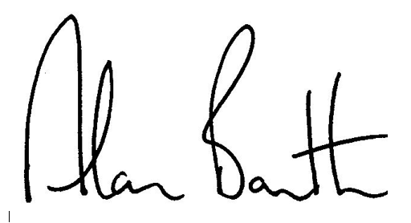

AB Associates
21 August 2024

